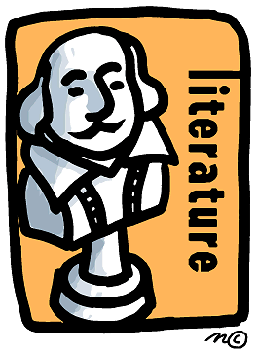

Concepts English 11

**September 3, 2019**

**DVHS OPEN House – Tuesday, September 3th 7-9 pm Tonight!**

**Picture Day- Friday, September 6th**

**Vocabulary Quiz- Thursday, September 5th**



This week in English class we are reading Act 1 of **The Crucible** by Arthur Miller.

"The Crucible" is about the Salem witch trials in 1692. Several young girls claim to be afflicted by witchcraft, starting with Reverend Paris's daughter Betty. The afflicted girls accuse people in the town of witchcraft, often choosing victims who they or their families dislike.

Contact information:

Alison Newman [Newmana@dvsd.org](mailto:Newmana@dvsd.org)

Chelsea Shatt [Shattc@dvsd.org](mailto:Shattc@dvsd.org)

We will update you with important information for Juniors throughout the year.

**[ACADEMICS]**

At the end of each act, students will answer guided reading questions, take a vocabulary quiz, and answer a constructed response question.

If they are on task, and use their time wisely, they can complete all assignments during class time. If they are absent, or having difficulty completing assignments, they are responsible to take it for homework to complete.

The vocabulary words are introduced at the start of each act, and reviewed daily for practice. Students receive a list of the vocabulary words they can take home for studying.

The constructed response questions deal with the subject matter in each act of the play. Students go back into the text to locate evidence to support the answers they use.

**Act 1 Vocabulary Terms (link below)**

The Crucible Act 1 Vocabulary Terms

[Lorem ipsum dolor sit amet, consectetuer adipiscing elit. Ut quam turpis, tincidunt ut, rhoncus nec, sagittis vel, erat. Morbi varius. Morbi varius tincidunt odio.

Maecenas porttitor, justo at cursus pharetra, diam enim semper mauris, vel condimentum nulla purus ac tortor.]